**Step 1: Open the Power BI project you created in the previous exercise, *Configuring a Star schema*.**

* Access the project from the file path in which it was saved and open it in Power BI.

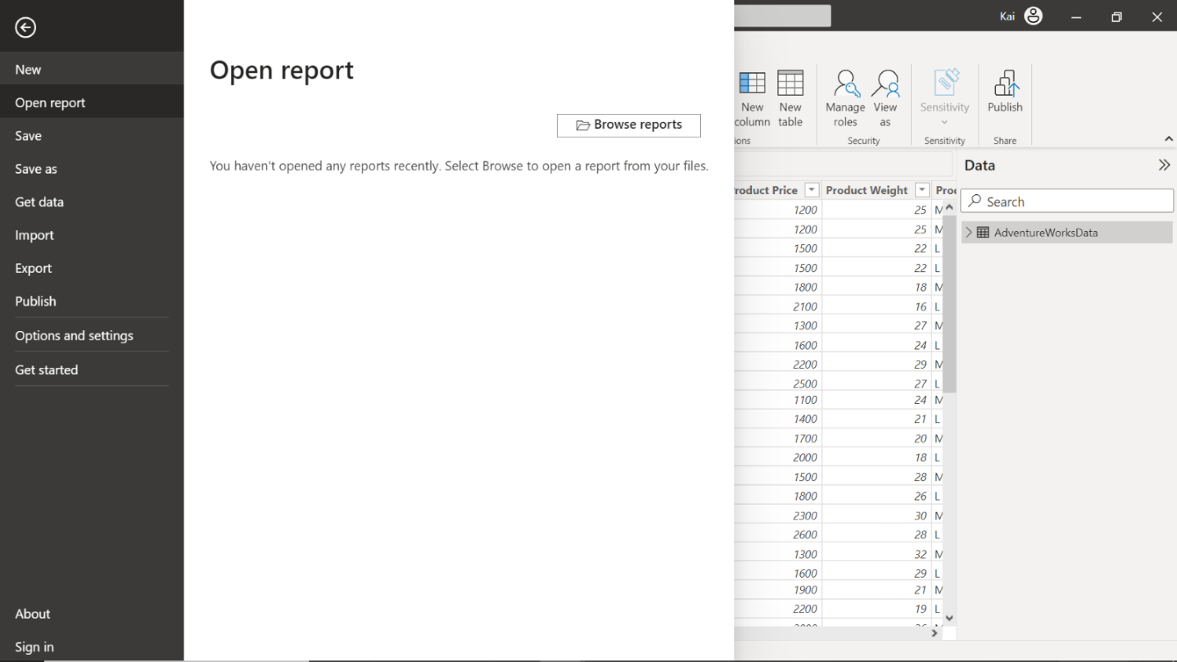

**Step 2: Identify the dimension tables in the star schema that can be normalized further into related tables.**

1. In the case of the Adventure Works star schema, two separate dimension tables can be normalized into look-up tables. These are **Product** and **Region**. You must normalize the **Product** table into **Category** and **Subcategory** tables to generate a Product hierarchy.

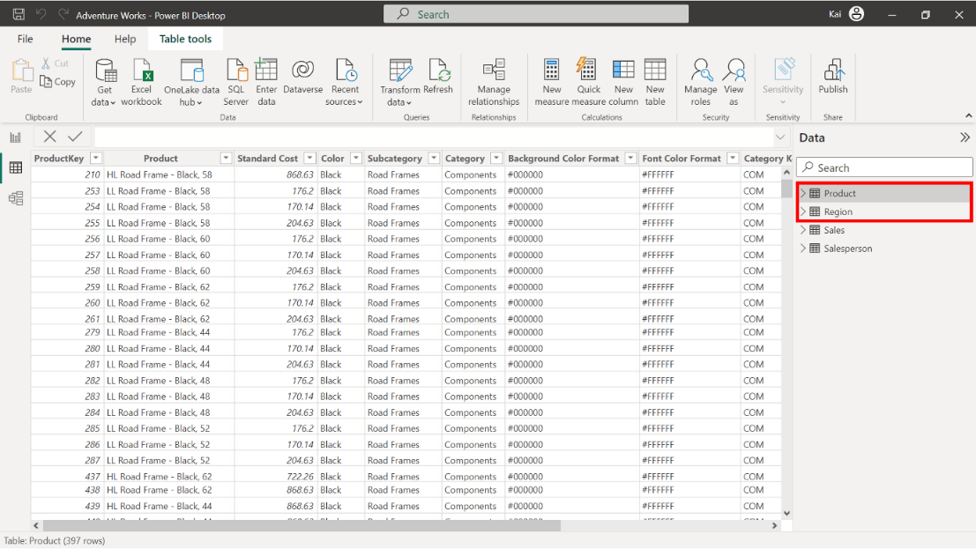

1. In the Power BI Data view, within the **Calculations** group, select **New Table**. Copy and paste the following DAX codes in the formula bar to create a new **Category** table. **Tip:** If you encounter an error with copy/paste, manually type the query. You’ll explore DAX in more detail in a later module.

1

Category = GROUPBY ('Product', 'Product'[Category ID], 'Product'[Category])

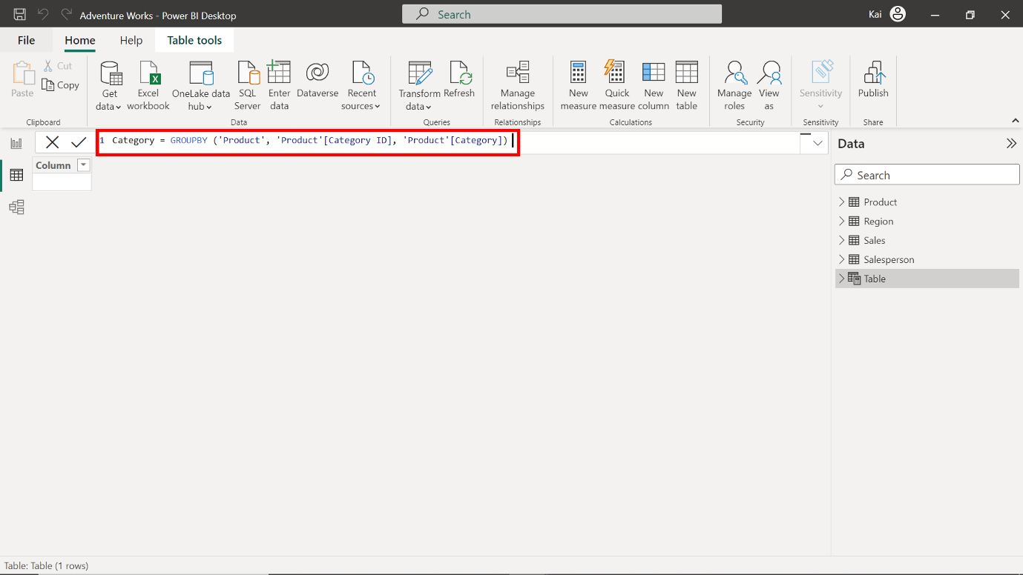

3. Once input, the DAX code generates a new table, as shown in the following image.

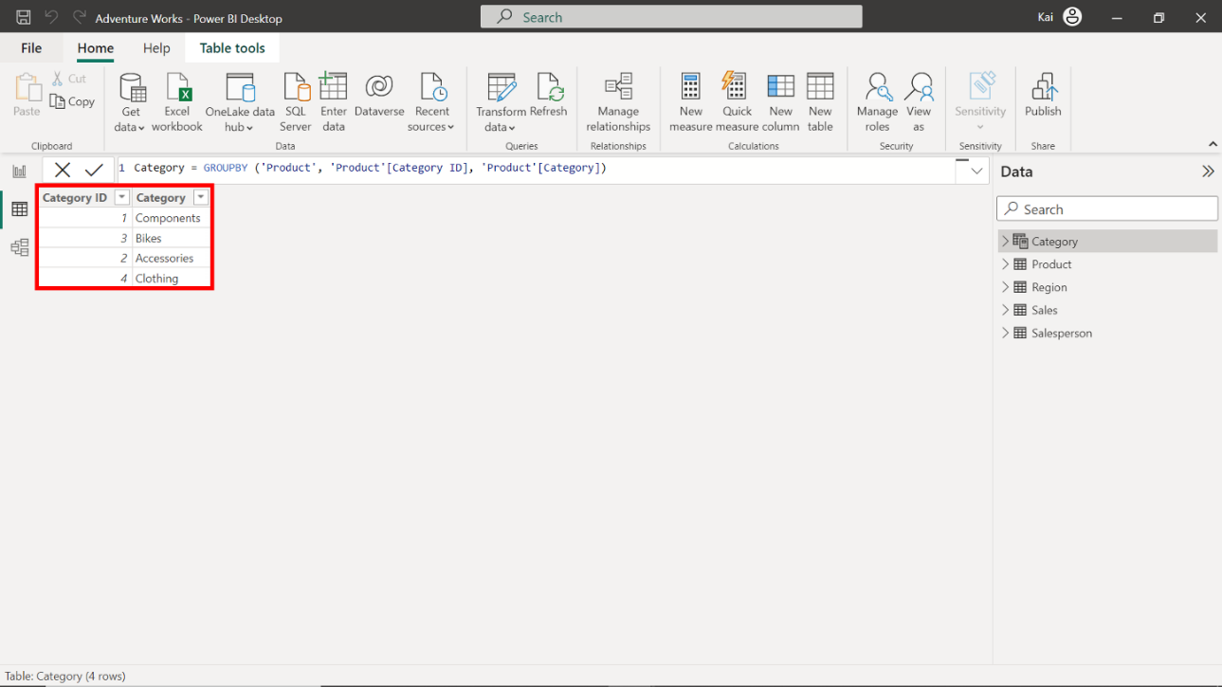

4. Repeat the same process to create a **Subcategory** table using the following DAX query. **Tip:** If you encounter an error with copy/paste, manually type the query.

1

Subcategory = GROUPBY ('Product', 'Product'[Subcategory ID], 'Product'[Category ID], 'Product'[Subcategory])

5. Once input, the DAX code generates a new table, as shown in the following image.

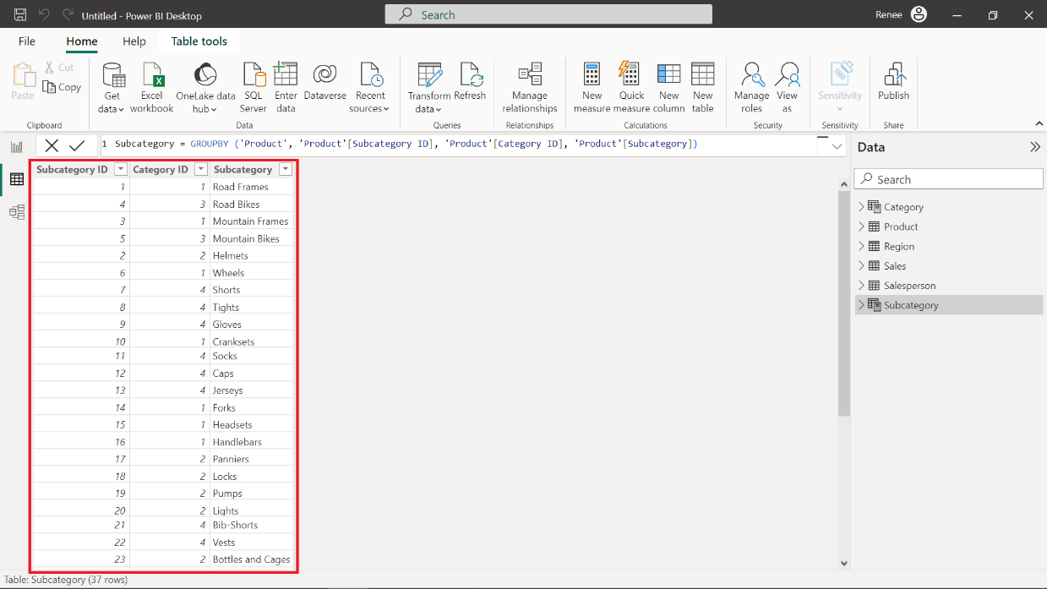

**Step 3: Configure the Snowflake schema.**

1. Once you finish creating new tables, Power BI attempts to autodetect and establish the relationships between these newly created tables and the already-existing tables. If relationships were automatically created, you need to remove these relationships. **Select** and **right-click** the **relationship connector**, then select **delete**.

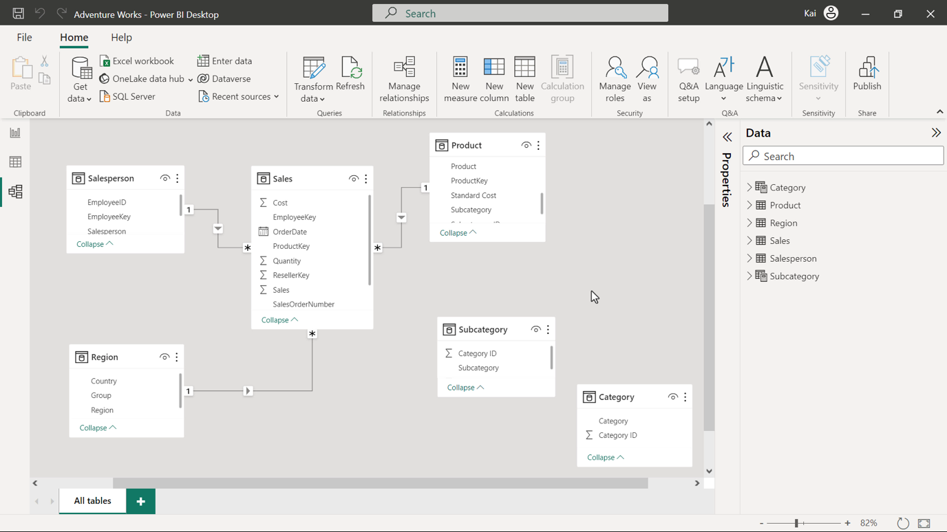

1. Create relationships between the **Product** table and **Subcategory** tables based on the **Subcategory ID**. Create further relationships between the **Category** and **Subcategory** tables based on the **Category ID**. You can create new relationships from the model view of Power BI desktop by selecting **Manage relationships** in the Home tab of the top Ribbon menu.

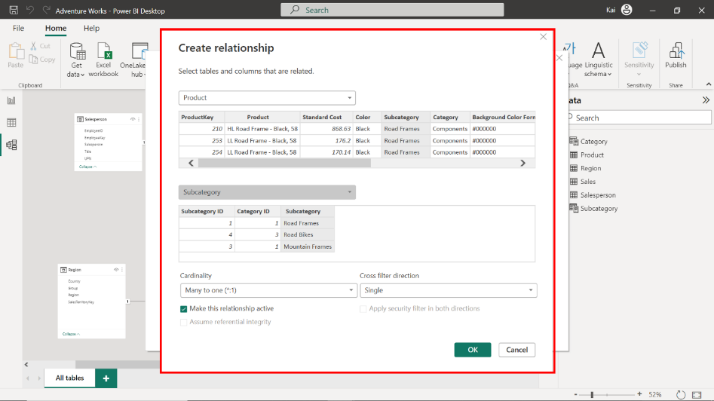

1. To configure these relationships, access the **Manage relationships** dialog box from the **Model view** of Power BI desktop. Make sure the cardinality for each relationship is set to **Many-to-one** and that all cross-filter directions are set to **Single**. These new relationships create a **Product** hierarchy. Any filter applied to the **Category** table now propagates to the **Sales** fact table to compute the **Sales** figures based on each **Product** category. This helps to analyze top-performing product categories and make strategic decisions.

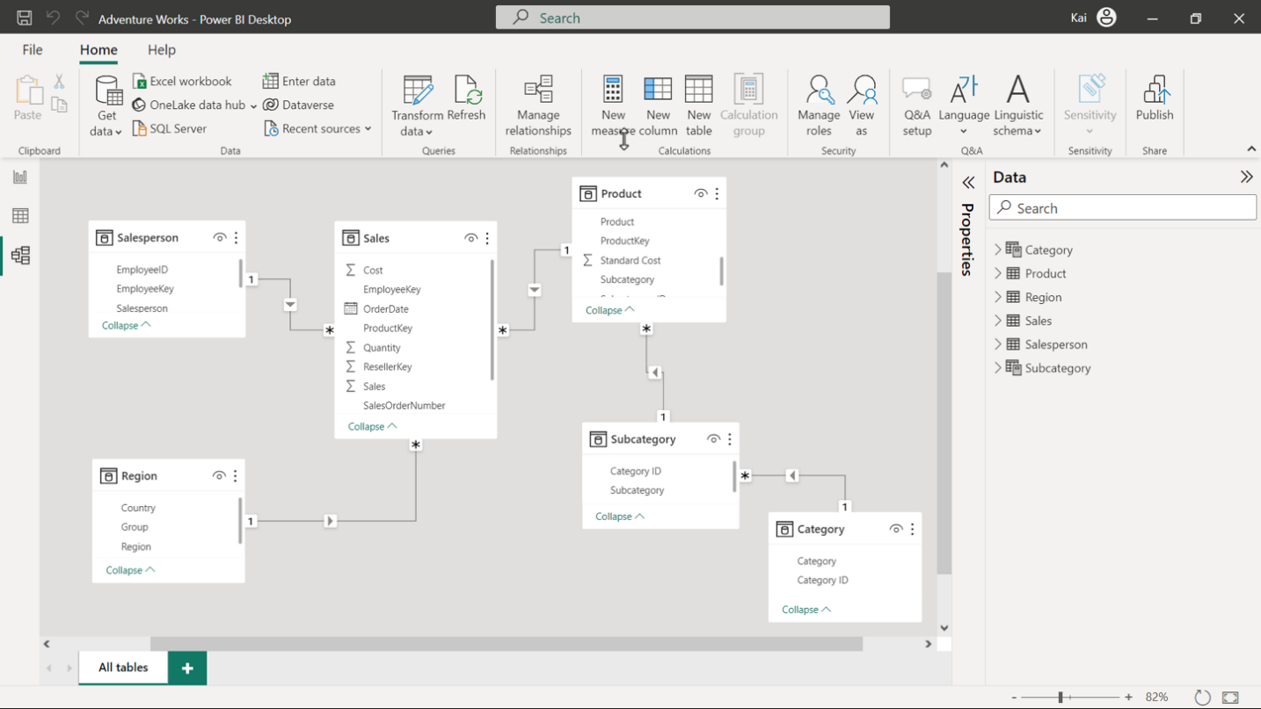

**Step 4: Save the project.**

* Save the Snowflake schema as a new project. Ensure to provide an appropriate name and path to the folder on your local computer.

**Conclusion**

Congratulations! You have successfully migrated a Star schema to a Snowflake schema in Microsoft PowerBI using the Adventure Works database. This new schema will allow for better performance and easier maintenance of your data model.

As an entry-level data analyst, mastering these techniques will help you build efficient and scalable data models for your organization.